Dear [[NAME OF PANELIST]]
Thank you so much for confirming your participation in the panel, “[[NAME OF PANEL]],” on [[DATE, TIME]] in/at [[LOCATION]].
Please send a brief bio (100 words) and a high-resolution (300dpi) headshot by [[DATE]]. I will be reaching out in the coming days to schedule a call with all panelists and our moderator. We will also be sharing a discussion guide for your review in advance of the call. Please feel free to reach out with any questions that come up in the meantime.
If you need to book accommodations, [[INCLUDE ANY INFORMATION ABOUT HOTEL RECOMMENDATIONS]].
Best,
[[Your Name]]
[[Your Title]]
[[Your Company]]
- Example Panel Discussion Guide
Panel Agenda
Set Up – 10 min
Research overview – 10 min
Introductions – 15 min
- Name
- Experience
- Current role/organization
- Why were you interested in joining this panel? Can you provide any insight based upon previous work/experience that you can share to help frame the issue?

Reacting to the Research Findings – 30 min
- Do any of these research findings surprise you? If so, which ones?
- Were you surprised to find that most non-African-American women, were less decisive when labeling the images as positive or negative, or the accuracy of such images? How did you interpret those findings?
- I thought it was interesting how perceptions of African-American women differ across media channels. Did the ranking of media channels surprise you? If so, how?
- How do you think these negative images impact how African-American women see themselves? What concrete evidence or facts do you have to support your perspective? Is this a greater concern for young girls/teens?
- Why should anyone (entertainment, advertising, client marketing execs) care? What do you say those who say ‘this is just entertainment’ or ‘they choose to watch these shows?”

Examining the Core Issue – 20 min
- What do you think is at the core of this problem? A lack of representation in creative industries (i.e., movie/films, TV, production, advertising), communication distributors (i.e., networks, social media, media planner/buyers), advertisers, news organizations? A lack of education among content creators? A lack of concern?
- Where does the breakdown occur? Is it a particular role? Or the process as a whole? Please explain the creative process and how these images are formed and distributed?
- Do you have examples of this occurring? Could you share any specific occasions? What was the outcome?
- Playing devil’s advocate, wouldn’t placing restrictions on storytelling have a negative impact on the creative product? Playing it safe doesn’t result in a great story, creative output. Isn’t this unfair to the creative process?
- Certainly, creating negative or harmful images is not illegal, but is it unethical? Who should be held accountable or voluntarily take responsibility?

Creating Solutions – 20 minutes
- How do you think the various industries should tackle this issue? Are there best practices that organizations should implement in the creative process? Media/planning and buying process?
- Could this be addressed with training within various crafts, not typical diversity training, but something more specific geared to copywriting, art direction, script writing, casting, etc?
- Social media can be tricky – an opportunity for self-expression and creation, but can be deceptive and uncontrollable. How can we leverage the power of social media to help create more balanced images while controlling the “fake and racist news” disseminated in social media? How can the tech and media communities work together to regulate “fake news”?
- Creating a more specific and straight-forward rating system for programming that occurs during prime time, and/or for unscripted TV programming has been discussed, as well as disclaimers for reality TV to better educate viewers. Do you think this approach could be useful?
- Media literacy programs have also been discussed as necessary tools to develop critical thinking skills in youth. If you were going to design an effective media literacy program, what would be the key components?
- Who is the “target” for media literacy/education efforts – youth/young adults, parents, educators?
- What role do you think public policy plays?

Spurred by the rise of so-called “fake news” and its impact on elections, a Santa Barbara state senator has introduced a bill that would encourage California’s K-12 schools to teach students to be skeptical, informed news consumers.

Authored by State Sen. Hannah-Beth Jackson (D-Santa Barbara), SB 203, known as the digital citizenship and media literacy bill, would require the state superintendent of public instruction to convene a committee of educators, librarians, parents, students and media experts to draw up guidelines on how best to recognize fake news.

As defined in the bill, media literacy “means the ability to access, analyze, evaluate, develop, produce, and interpret media and encompasses the foundational skills that lead to digital citizenship.” Digital citizenship “means a diverse set of skills related to current technology and social media, including the norms of appropriate, responsible, and healthy behavior.”
Source: EdSource.org

Q&A – 20 minutes

- Sample collateral materials
Adrianne to update for me

Sample Eblast

Sample Event Signage

Sample event collateral

- Registration tools
When sharing information about the event, registration links should require the following information:
- Name
- Title
- Company
- Contact Email
- Address
- Would you like to receive follow-up information regarding future programming of a similar nature?
The below websites are tools you can use to collect registration information for your event:
- Eventbrite
- Paperless Post
- Google Forms

- Sample Social Media Posts

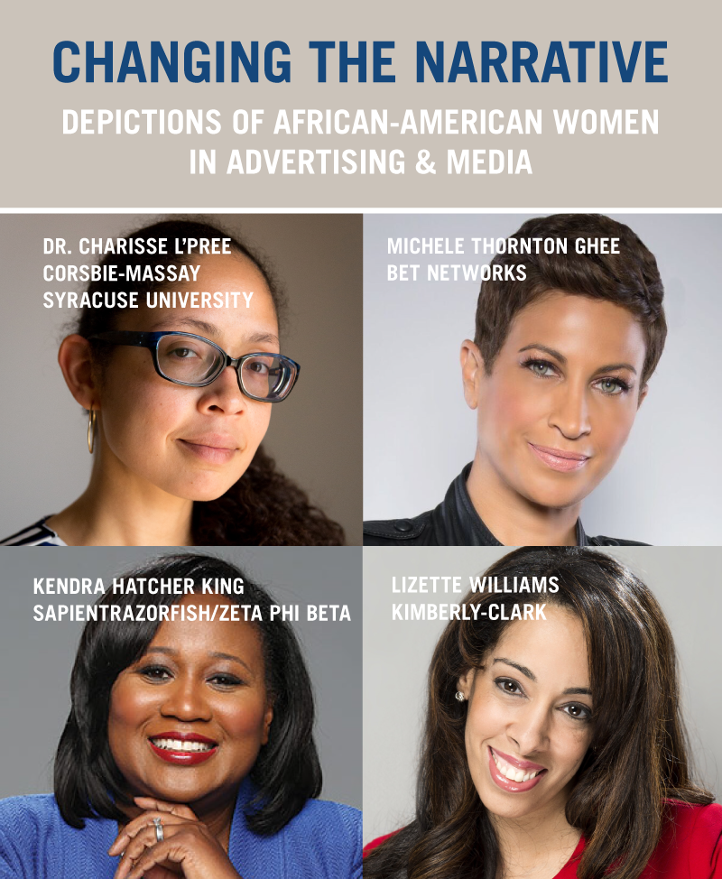

CAPTION: 67% of African-American and Caucasian female millennials believe African-American women are depicted negatively in the media, while a mere 13% view images of African-American women in the media positively. Come hear these shocking results from our groundbreaking study. Register here (LINK)

- Potential Attendees & Partners

If considering partnerships and sponsors, think beyond monetary exchange. For some organizations, providing printing services or food for the event is easier than providing funding.

When considering attendees, create an invite list that not only includes your organization’s contacts but academic groups; local professional clubs focused on advertising, media, public relations, communications or other related industries; advocacy groups and other groups in your community that are active in creating change.

